- Give regular expressions generating the following languages over {0,1}*:
  - {w | w begins with a 1 and ends with a 0} 1( 0 $∪$ 1)*0
  - {w | every odd position of w is a 1} (10 $∪$ 11)*1 or (01 $∪$ 11)*
  - {w | w is any string except 11 and 111} ${(0 ∪ 10 ∪ 110 ∪ 1110 ∪ 1111)}^{+}$(0 $∪$ 1)* $∪$ $ε$
Convert the following FA into a regular expression with the procedure described in class.
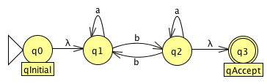
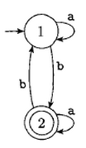
First, add G-initial and G-accept states.
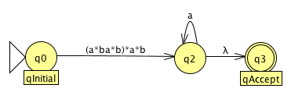
Second, choose a state to remove and replace for its actual regular transition expression, in this case I chose q1.

Third, another state to remove and replace for its actual regular transition expression, in this case I chose the only one left q2.
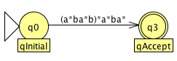
Finally, you end up with the actual regular expression representation of the GNFA.

- Convert the following regular expression into a NFA using the procedure described in class.
a(abb)* union b.
Do not simplify.
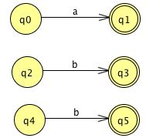
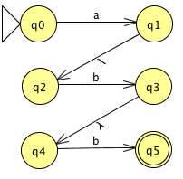
First, start with the inner operations. In this case, abb. Build each system independently and then combined according to its given operation, in this case, concatenation.

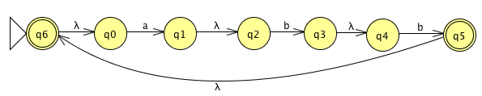
Second, proceed with the closest outer operation. In this case, start operation.
Third, proceed with the next closest outer operation. In this case, concatenation for which another system must be built in order to concatenate it with the one already built.
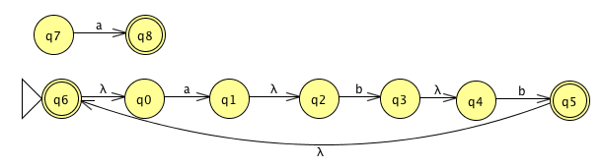

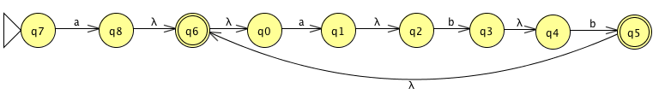
Finally, since no more outer operations are left we have obtained a complete NFA of the given regular expression.

- Given a language L, let Prefix (L) be the following:
{x | xy is in L, x, y in Sigma^{star}}

Show that if L is regular, Prefix (L) is regular. You only need to do an informal description and explanation. Formally define your construction for extra credit.

Assume that L is regular we can construct a new NFA M’ equivalent to M except that we add a new state q’, which is the only final state in M’. Afterwards, we add epsilon transitions from all states from which final state is reachable in M to q’. If xy is in L, then x is consumed by the regular transition M followed by one of the epsilon transition to q’ to simulate the consumption of y consuming something. Therefore, L’ (M’) = prefix (L (M)) = prefix (L), that is if L is regular, then prefix (L) is also regular.
More formally, we can create a new DFA M’ for any regular language as follows: M’ = (Q, Σ, δ, q0, Q−F’’), where F’’ = {q ‘∈ Q: a path from q’ to an element of F}.

Five Tuple Example:
Q’ = Q U q’, where q’ is the new state added with an arrow to each final state.
$∑$ = $∑$
q0 = q0
$δ'$ = $δ$
F’ = Q – F’’, where F’’ = {q’ ∈ Q: there exists a path from q to an element of F}.
The resulting set of states equals F’.

We can decide F’’ as follows:
- First, reverse all arrows in M.
- Second, add a new state q’ with an arrow to each ﬁnal state in F.
- Third, determine all states that are reachable from q’.

Subsequently, L (M’) = Prefix (L), where Prefix (L) = Σ* if and only if L (M’) = ∅.

  - Let B = {1^{k}y | y in {0,1}* and y contains at least k 1's, for k >= 1}.
B must always start with a “1” according to the language it accepts. Therefore, any NFA/DFA for a subset of B must first accept a 1.
This can be shown as follow:
B’ = {1y | y is in {0,1}* and y contains at least a 1}
For all string w in B, w can be written as 1ky for some k>= 1. Now, we can say that w = 1$1^{k-1 }$because there is at least k1’s in y and k >= 1. Therefore, the number of 1’s in the substring $1^{k-1 }$-1y>= 1 for what w is in B’. Since A is a subset of B and B a subset of B’, we can say that B = B’ and by proving that B’ is regular we are proving that B is also regular.
We can easily draw a DFA for B’ as follow:
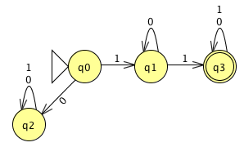
  - Let B = {1^{k}y | y in {0,1}* and y contains at most k 1's, for k >= 1}.
Assume, for a contradiction, that B is regular. Then, B must have a length m >=p, where p is the pumping length.

Let w = xyz be the partition given by the pumping lemma.
|y| > 0
|xy| <= p
and x$y^{i}$z is in B for all i>=0;

Now we find for a string s of length p that is in the language:
Let s = $1^{p}$0$1^{p}$ = x$y^{i}$z, where p is the pumping length.

According to the pumping lemma partition:
x$y^{i}$z = $1^{p}$0$1^{p}$, for any i>=0.

Now, we pick the value for i, let i=0, and we get the following:
xz = $1^{p-t}$0$1^{p}$,, where t > 0 since |y| > 0.

For xz to be$∈$ B, xz must = 1^{k}y for some k, where the number of 1’s in y <= to k.

From the string 1^{k}y = 1^p-t 01^p we can deduce that y must contain the substring 01^p. So k<= p-t, while the number of 1’s in y>=p. y will always be grater than k since t>0, and this shows that xz can’t therefore be in the language. This is a contradiction, thus
B cannot be regular.

